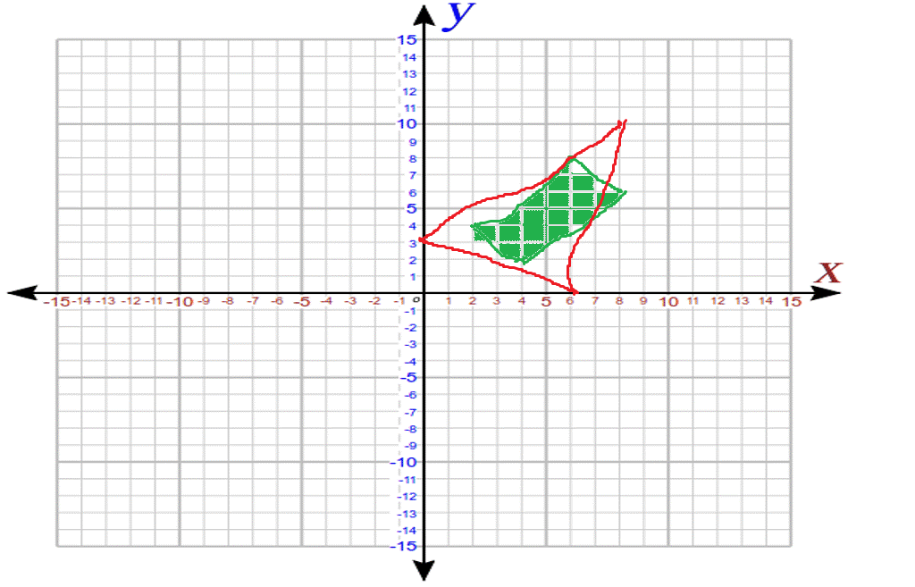

The objects are clearly overlapped as you can see the triangle nearly fully covers the rectangle.

8<3 OR 0 > 8 **FALSE**

8<0 OR 10 < 2 **FALSE**

**Objects are colliding**

In the **Collider** example (Module 11, Slide 25), please explain how the run method works?

The run method instantiates an interator. While there are still objects to go through, it moves every moveable object using the move method.

It then resets the iterator to theWorld to ensure that moving has not caused collisions between objects.

It creates an object that is acapable of colliding with the next object in iterator.

The second iterator is used to get a second object in the same way.

The otherObj!=curObj ensures that you’re not using the same object for both.

This process is repeated until the iterator reaches the end.

It then checks if the object has collided, and then handles the collision. The final repaint() goes to paint which redraws the game world.